TASK 7 – EVALUATE PROCESS CONTROL SYSTEM CALLS
Course Code: CSA04
Course Name: Operating Systems
Course Outcome: CO1
Marks: 4
Full Question
Evaluate how a small command shell launches and controls jobs.
Discuss:
- fork(), exec(), wait() and exit().
- How a shell launches a command and collects its exit status.
- What happens if the shell does not wait.
- Zombies and orphan processes.
- Why fork() followed by exec() is useful.
Complete the code using fork(), execlp() and waitpid().
AIM
To demonstrate process creation, program execution and process termination using fork(), execlp() and waitpid() system calls.
ANSWER
1. Introduction
Process control system calls are used to create, execute, manage and terminate processes.
A process is a program in execution. Each process has its own process ID, memory space and execution state.
The main process-control system calls are:
System Call | Purpose
fork() | Creates a new child process
exec() | Replaces the current process with another program
wait() | Waits for a child process to finish
waitpid() | Waits for a specific child process
exit() | Terminates a process
2. Working of a Shell
A shell is a command interpreter that accepts commands from the user and executes them.
The shell performs the following steps:
- Receives a command from the user.
- Creates a child process using fork().
- The child executes the command using exec().
- The parent waits for the child using waitpid().
- The parent collects the child's exit status.
- The shell continues to the next command.
3. C Program
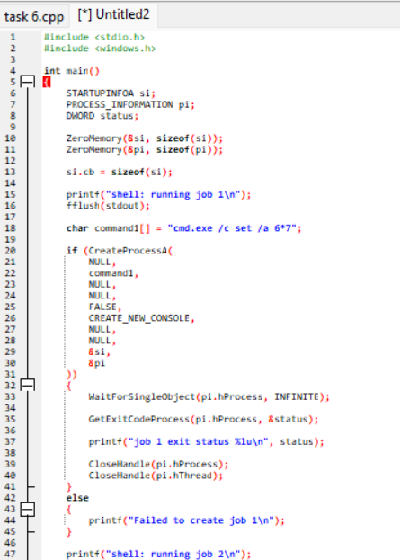
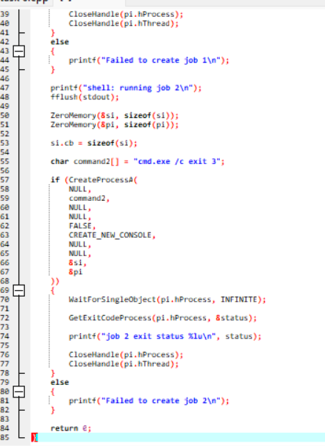
4. Expected Output
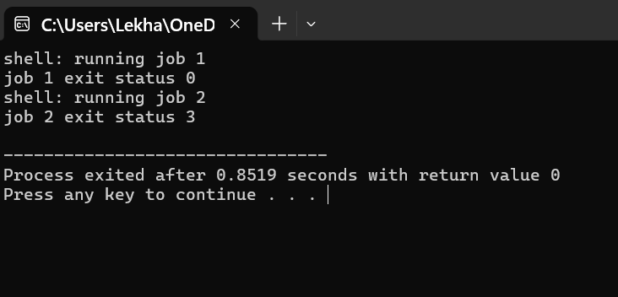
5. Explanation
The first job creates a child process using fork().
The child executes the expr command through execlp(). The command calculates:
6 * 7 = 42
The parent process waits for the child using waitpid().
The second job creates another child process. This child terminates with exit code 3.
The parent collects the exit status and prints it.
6. Why fflush(stdout) Is Used
The fflush(stdout) function flushes the standard output buffer before creating a child process.
When fork() is executed, the child receives a copy of the parent's memory, including any buffered output.
If the buffer is not flushed, both processes may print the same buffered text. This can cause duplicate output when stdout is redirected to a file.
7. Zombies and Orphans
Zombie process:
A zombie is a terminated child process whose exit status has not yet been collected by its parent.
It remains in the process table until the parent calls wait() or waitpid().
Orphan process:
An orphan is a child process whose parent terminates before the child finishes.
The orphan is adopted by a system process that manages its termination.
8. Alternative Concept – posix_spawn() or Threads
If posix_spawn() is used instead of fork() followed by exec(), the program can launch a new process using a single API operation.
Factor | fork() + exec() | posix_spawn() | Threads
Process creation | Two-step approach | Simplified approach | Creates thread
Memory | Copy-on-write | Efficient process creation | Shared address space
Isolation | Strong | Strong | Limited
Startup overhead | May be higher | May be lower | Usually lower
Resource sharing | Separate processes | Separate processes | Shared memory
For a shell, fork() and exec() are useful because they provide process isolation and allow the child to execute a different program.
For launching many external commands, posix_spawn() may reduce overhead.
Threads are suitable for concurrent tasks within one application but do not provide the same isolation as processes.
CONCLUSION
The experiment demonstrates process creation, execution and termination using system calls. The combination of fork(), exec() and waitpid() provides an effective method for launching commands and collecting their exit status. Waiting for child processes prevents the accumulation of zombies and improves process management.

